Silverdale School
KS5 A/S A2 Level Art Department Handbook
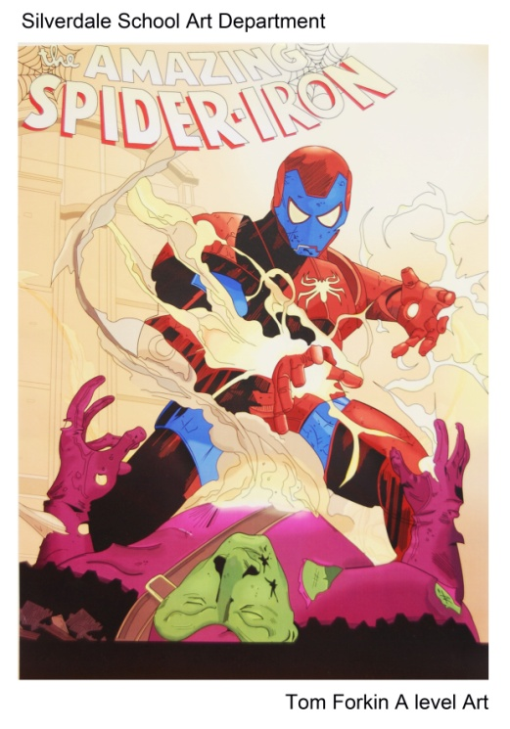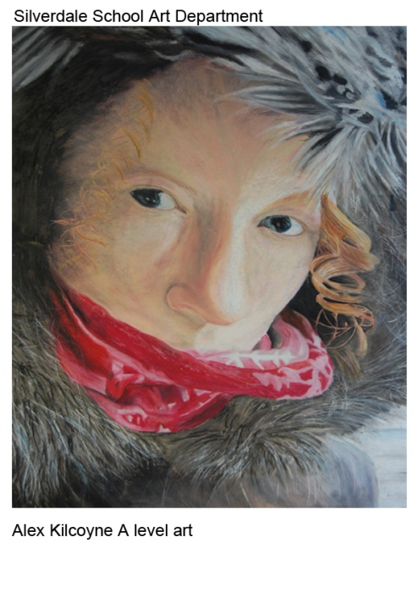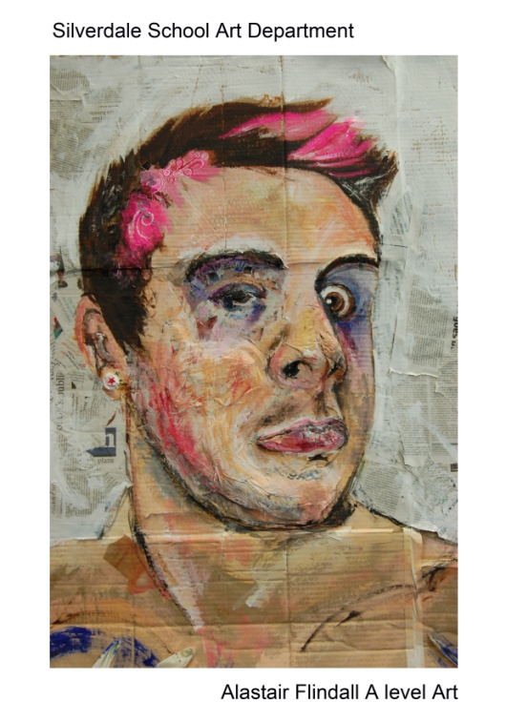
Information and Advice for students

Art Department Ethos:
- We want all students to develop their creative and critical skills from KS4 to the higher levels expected at KS5
- We want students to explore their individual artistic and creative interests as thoroughly and as highly as possible
- We will push students to raise their quality of work and use the regular marking of work to ensure that progress is monitored and the students are fully informed at all times
- We will ensure that students are informed by high quality classroom teaching enhanced with trips to galleries and workshops with artists / craftspeople.

Course Outline:
A/S Fine Art – AQA Exam Board
This is a 1 year course and includes 2 projects. It evolves neatly from AQA GCSE Art course as the assessment objectives are the same. But keen students can be successful if they work hard to manage the requirements.
You have 2 teachers, both experts in a broad range of drawing, painting, printing and photographic processes. Lens based media is also available to use in the course. You will develop your creative skills in a double and treble period of time a week plus 2 hours homework time a week.
We expect 3 studies to be produced a week in the lessons and with homework.

The 2 projects are separate and include ‘A Portfolio Project’ which lasts from September to February 1st and an ‘Externally set Assignment’ which lasts from February 1st to May. We give students deadlines for each objective and expect work to be produced to meet the deadline.
Students design their own ‘Portfolio Project’ using a ‘Proposal sheet’ and the teachers respond by finding artists, designers and craftspeople for the student to begin showing critical understanding of the work. Students are given a sketchbook and a large folder to organise their work.
The ‘Externally set Assignment’ begins with the exam board list of starting points and the student selects their choice and the process evolves as with the ‘Portfolio Project’.
Work is regularly assessed to ensure that the student knows how they are performing.
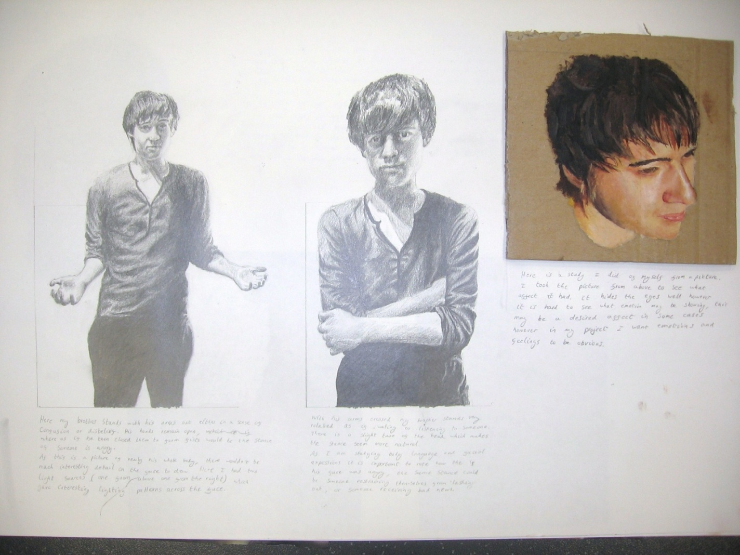 Example of ‘Portfolio Project’ sketchbook work. Justin Boyd

Proposal for Art ‘Portfolio’ Project
Name: Form: .
Choose your question carefully based on your interests and also your strengths. You may work in the materials of your choice, especially if you have been successful with them. Art projects are marked as a whole but are broken down into 4 assessment objectives: (A01, AO2, AO3, AO4) and they are each worth a maximum of 20 marks. Remember studies are not expected to be finished pictures, you score marks by demonstrating your skills and being selective. Good luck!
Chosen title from the exam paper: __________________________________________________________
Brief description of what subject you are focussing on and any other information which will help your teacher to focus your critical sources.
AO1: Learning about the subject by copying art, design, cultures. Write the names, titles and webpage addresses of artists, designers and cultures used.
Teacher suggestions: | Your own suggestions:
AO2: Experiment and explore ideas, materials and processes that you might use for your final piece. Photographs, drawings, paintings, exploring surfaces, exploring mixed media, 3D, modroc, Experimenting with compositions using Photoshop and cut-n-paste techniques.
AO3: Recording accurate observations which will help to inform you about your subject. Photographs, drawings, paintings, Photoshop/cut-n-paste compositions.
AO4: The final piece which evolves from your prep work above. This needs to be personal, to evolve from your own experience, informed by your research into artists and techniques done in the objectives above.
Course Outline:
A2 Fine Art – AQA Exam Board
This is a 1 year course and includes 2 projects which will develop experience and ability from the previous year’s A/S course.
You have the same 2 teachers and you are expected to develop your creative skills further in the double and treble periods of time a week plus 2 hours homework time a week.
We expect 3 studies to be produced a week in the lessons and with homework.
As with the AS course students will be regularly assessed and work will be monitored to ensure progress is made.

The 2 projects are separate and include ‘A Journal Project’ which lasts from September to February 1st and an ‘Externally set Assignment’ which lasts from February 1st to May. We give students deadlines for each objective and expect work to be produced to meet the deadline.
Students design their own ‘Journal Project’ which starts from the student’s own experience of art / design work / crafts work that they have experienced directly. The students are expected to show a thorough understanding of the art work(s) they are studying which includes a written journal response (1000 words). Students are given a sketchbook and they use the other side of their large folder to organise their work.
The ‘Externally set Assignment’ begins with the exam board list of starting points and the student selects their choice and the process evolves as with the ‘Journal Project’.
Work is regularly assessed to ensure that the student knows how they are performing.
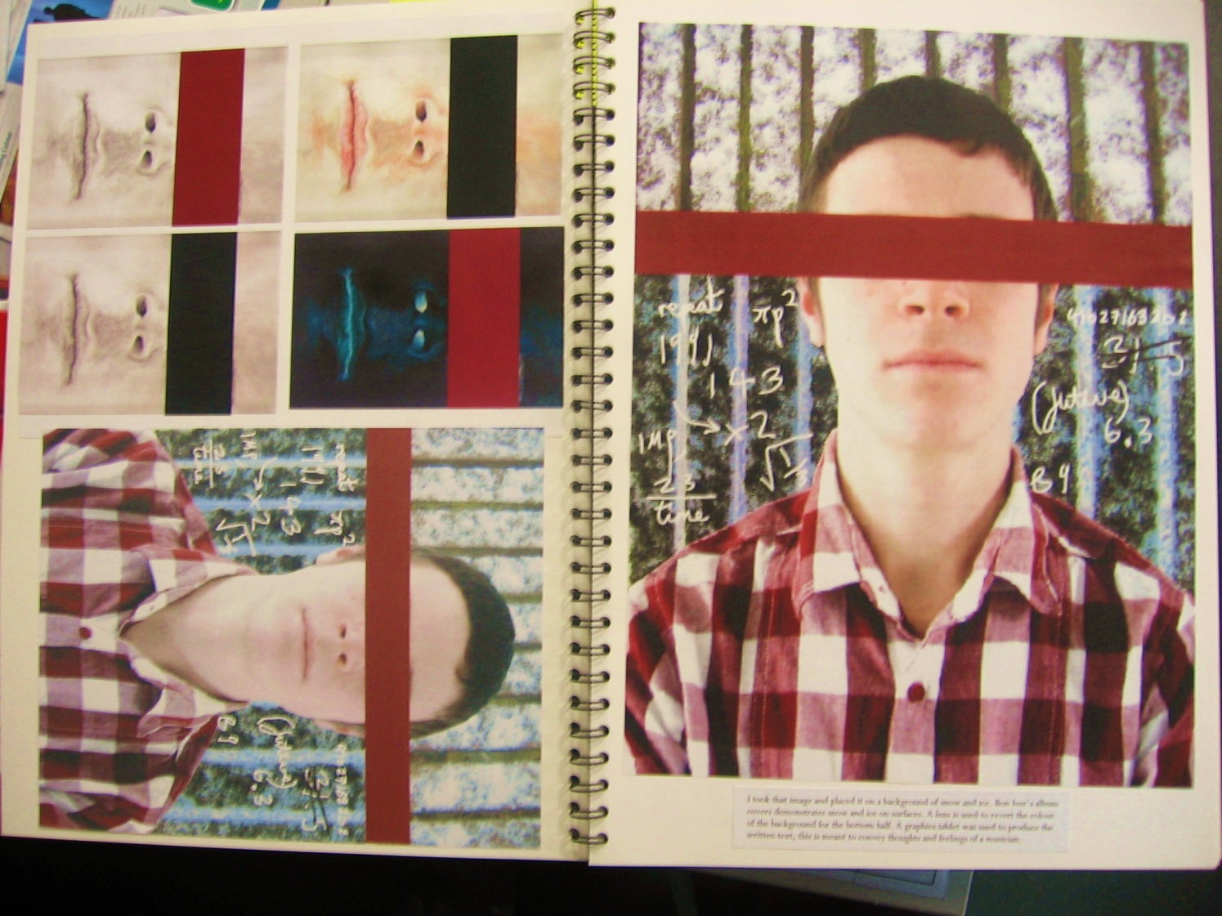
Tom Rogers Page of ‘Journal sketchbook’
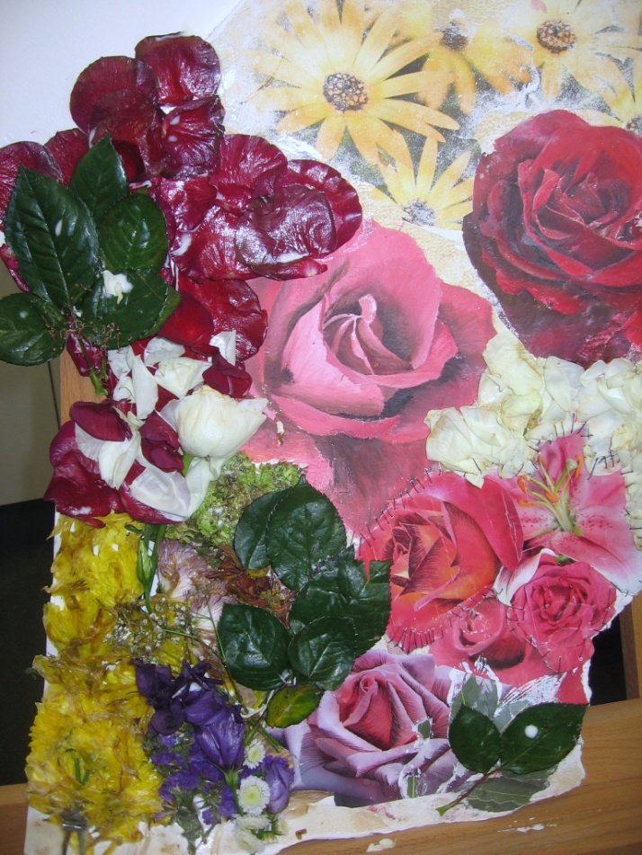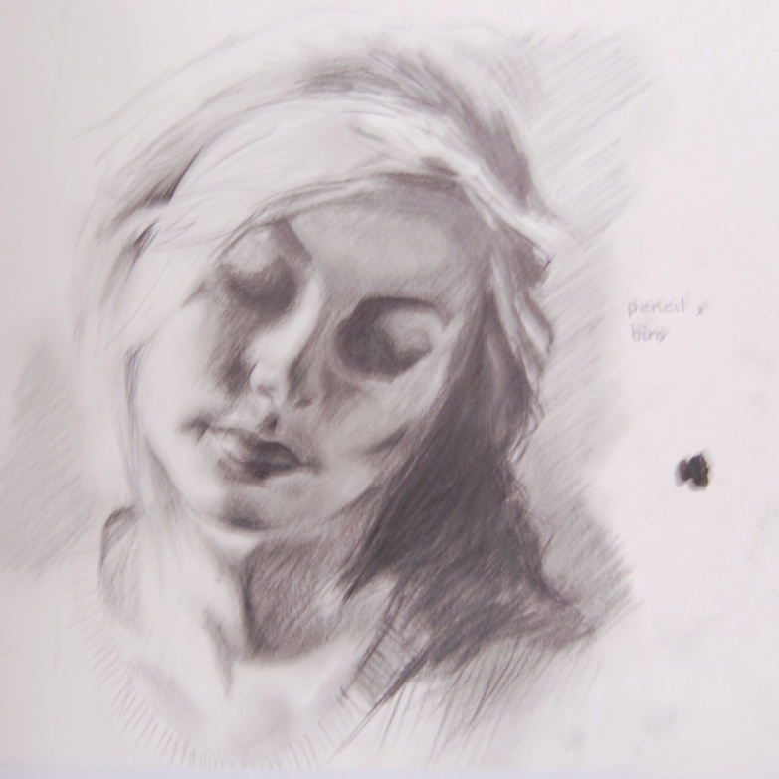
Jess Wilson Composition experiments for ‘Journal Project’ Hannah Ustun Observational study for ‘Journal Project’

What does the subject lead to 1?
Points for a valid A level towards University Application (UCAS)
- Art & Design A level is valid for most academic subjects at university (including Law and Medicine) However, it is sensible to check before applying.
- Generally Universities are more than happy to accept students onto academic courses if they have 2 or more academic subjects and one arts based A level
- Universities may be looking for a creative approach to their course and require applicants to have a multi-disciplinary approach to their studies

What does the subject lead to 2?
Preparation for entry to an Art Foundation Course
- An Art Foundation either at Chesterfield or Sheffield College (or any University that offers it in the UK) is an excellent way of developing creative skills in much greater depth. The course is full time and includes modules in figure drawing, photography, digital manipulation, fashion design, design, fine art, 3D design.
- Students develop their skills and apply to university with a full and specific portfolio which is focussed for the degree course they have chosen.
What does the subject lead to 3?
Preparation for entry to an art based degree
- Art degree are usually 3 years long and usually require the student to have undertaken a Foundation course before applying. (Again, it is worth checking the website or contacting the university directly to understand the entry requirements)

Extra-Curricular Opportunities:
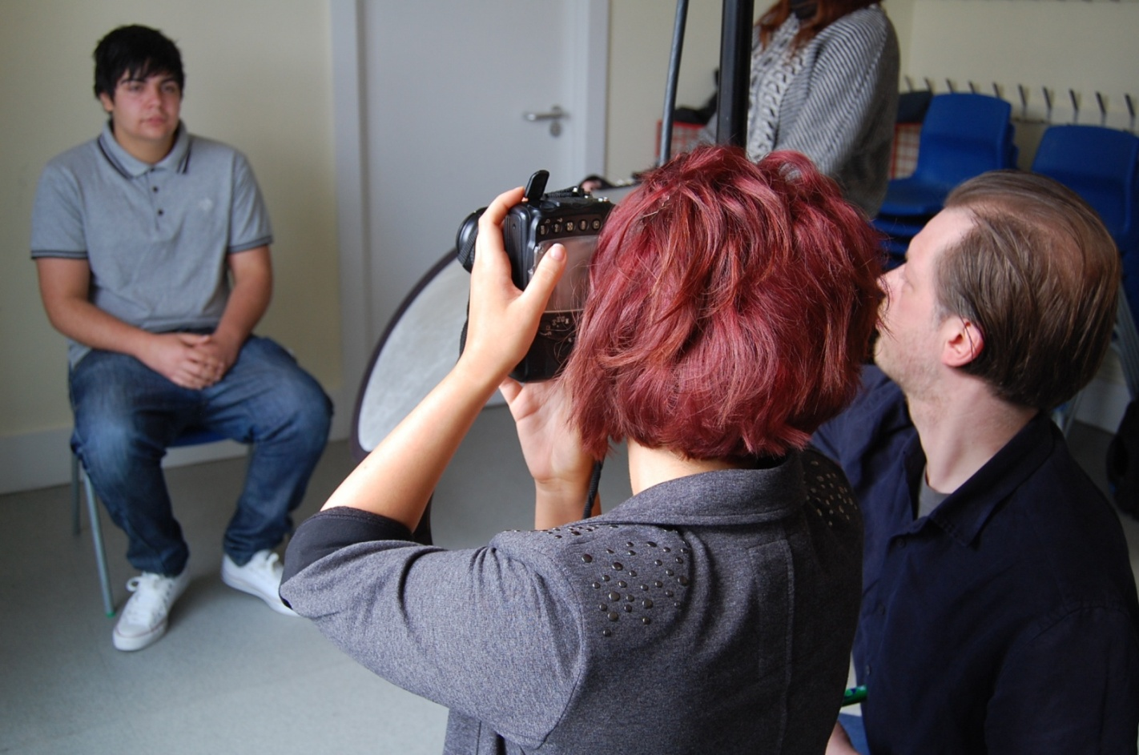
Photography workshop at the Graves art gallery with Chris Saunders

Arts Trip to New York every 2 years
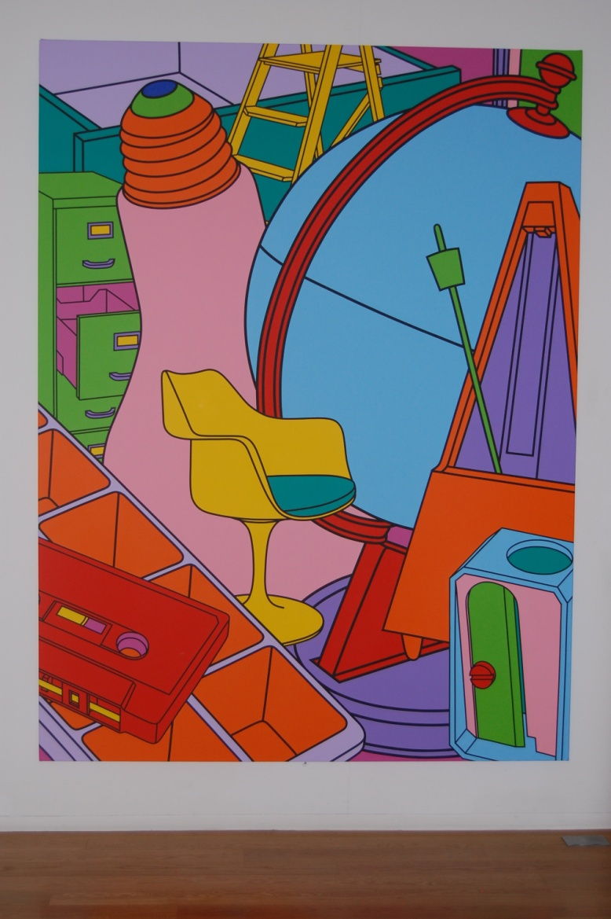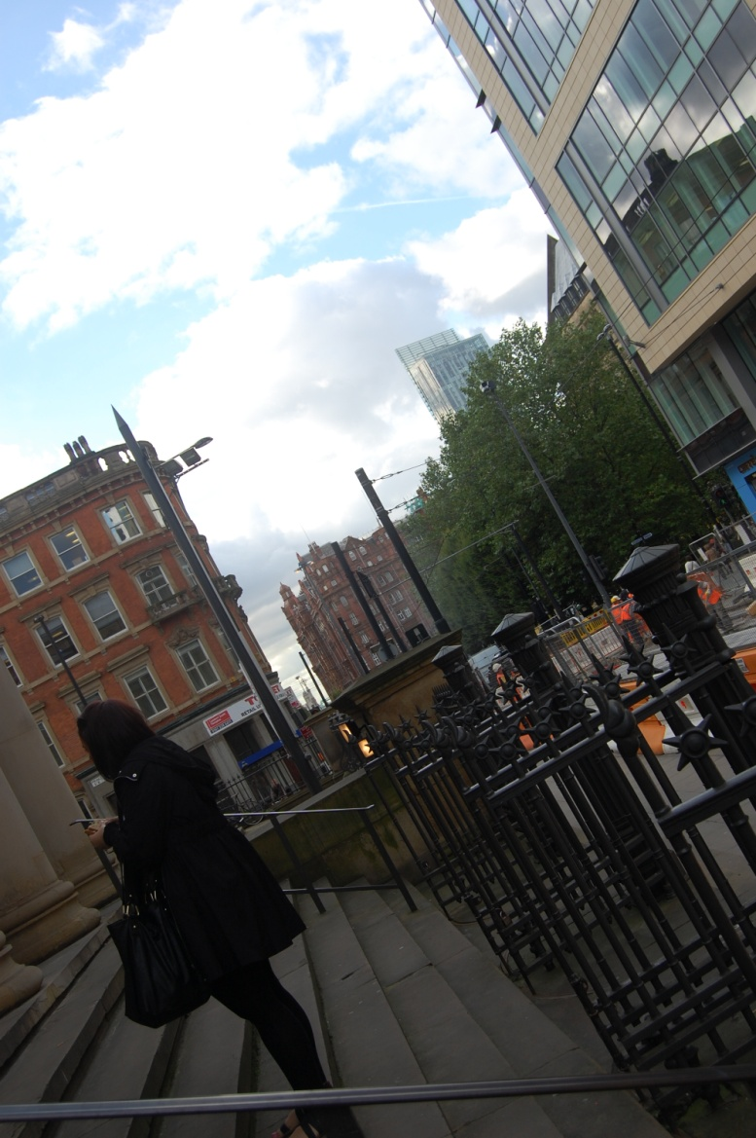
Y12 Research trip to Manchester Art Gallery to study art and create visual research in the city

