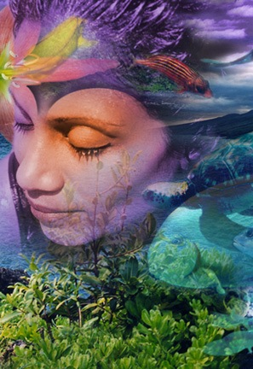
GCSE Photography 'Metamorphosis'
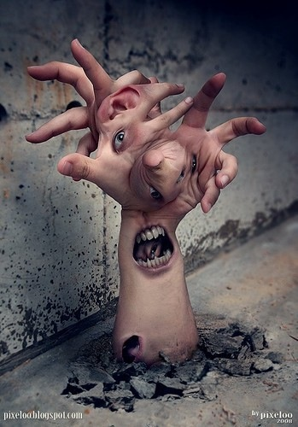
AO1 SHOWING AN UNDERSTANDING OF RELEVANT ART / PHOTOGRAPHY. - 8 Studies, 5 weeks, 13 lessons, can be presented digitally or in a sketchbook

- Research the 'Creative Spark' photography exhibition. Students select 3 student displays that are impressive. They photograph the work and present it to show understanding of how it was made? and why they like it? (3 lessons)
- Homework: Show an understanding of Magritte using his 'False Mirror' picture and 'The Double Secret' picture. Students present their understanding with an example of the artists work and take their own pictures for digital work in the classroom.
- Students create own version of Magritte pictures using photoshop. (1 lesson)
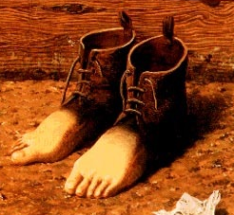
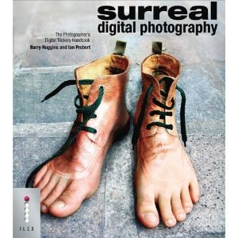
- Students use lighting and studio set up to create own combined images inspired by Magrittes 'the red model' and 'Collective invention' pictures. Use photoshop to demonstrate combination techniques. (2 lessons)
- Homework: show an understanding of Georgia O'Keeffe's landscape and close-up art. Students present their their understanding with an example of the artist's work and take their own pictures of landscapes for work in the classroom. (2lessons)

- Holiday homework: Students find an example of art which shows metamorphosis and present their own understanding of the art. Using pictures and annotation.
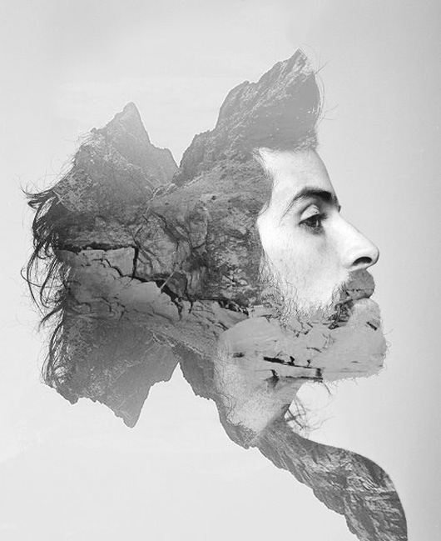
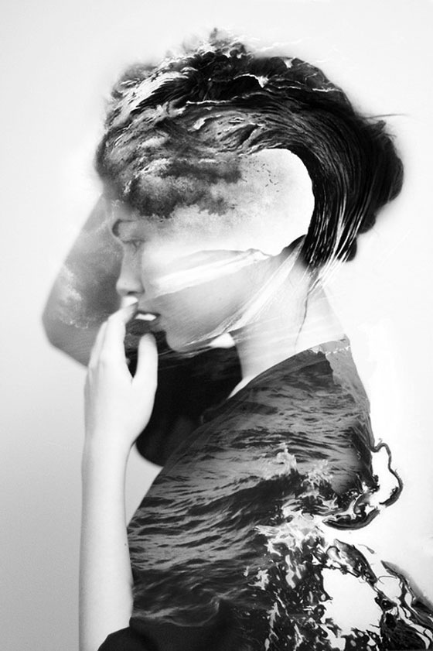
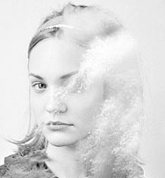
- Students create profile photographs of each other inspired by the landscape/portrait metamorphosis art of Matthew Wisniewski. Using photoshop they combine the profile photographs with richly textured landscape pictures. (2 lessons)
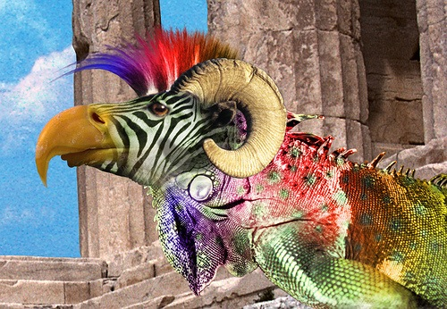
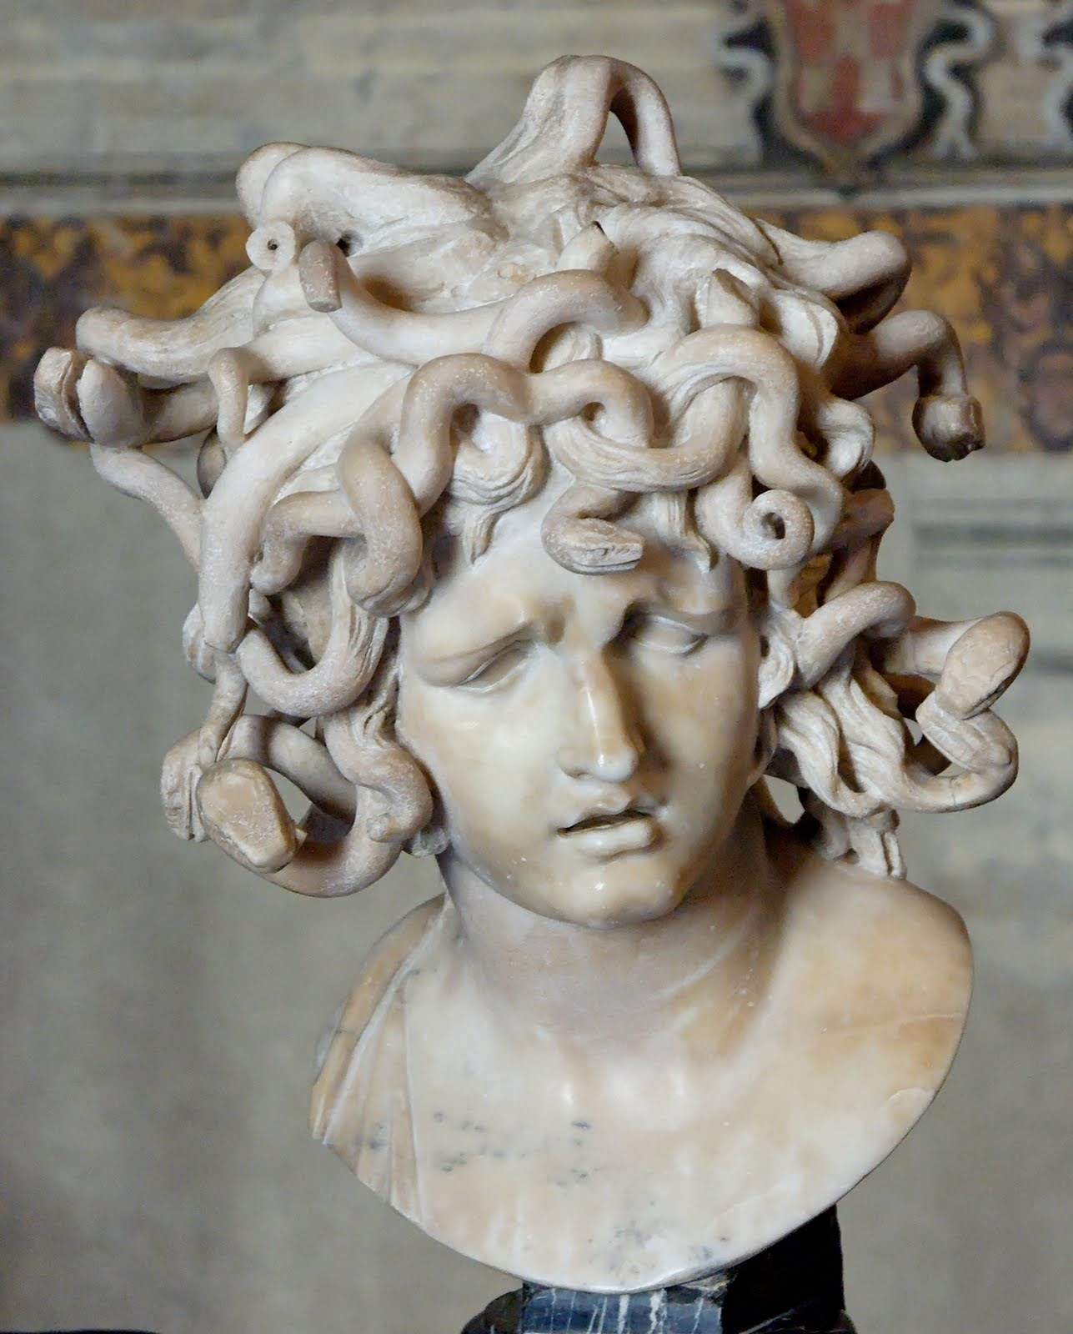
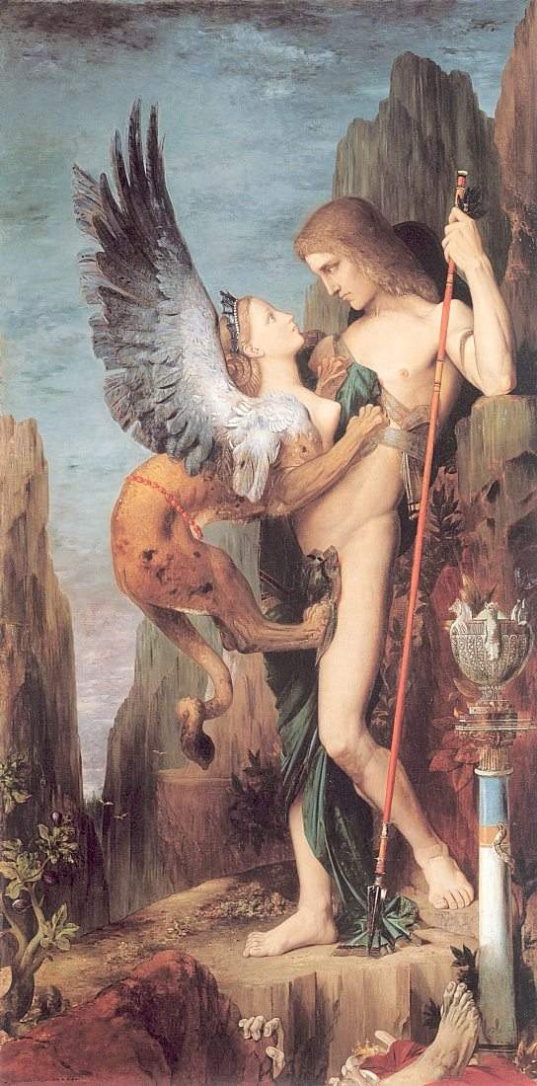
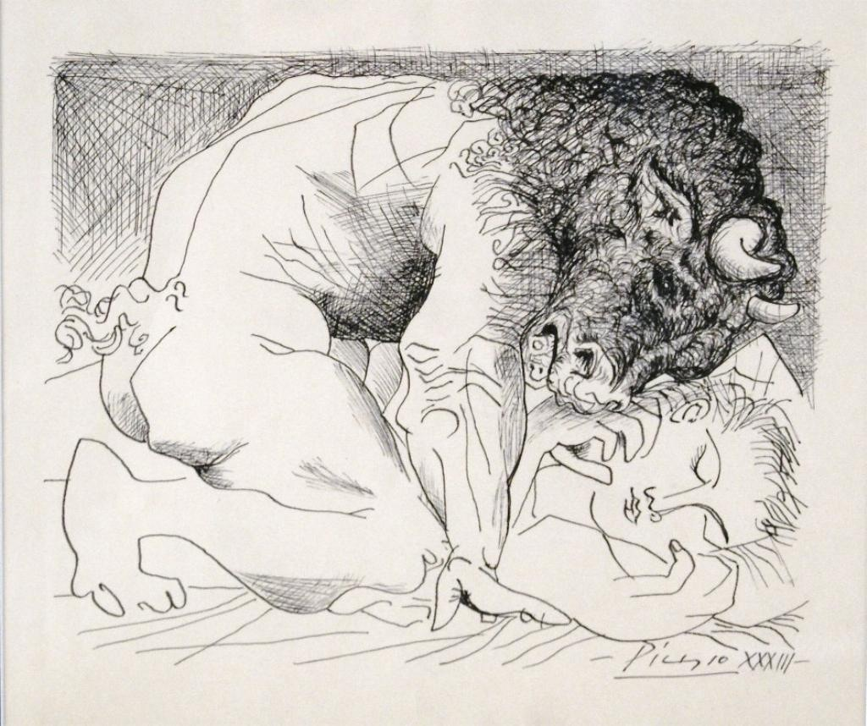
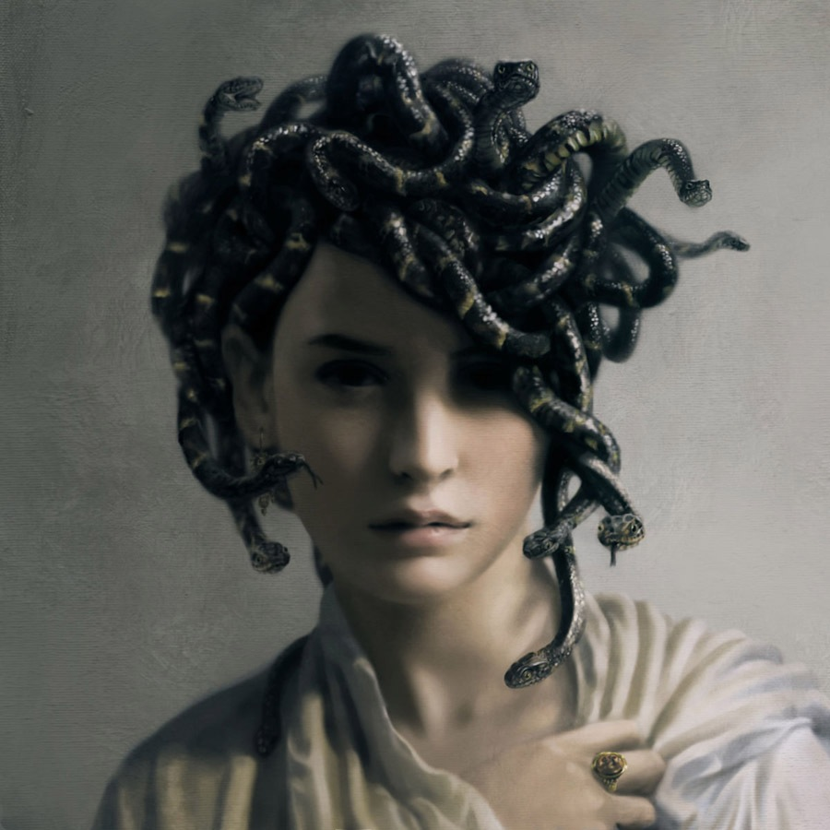
- Students create their own mythical characters inspired by mythical art. Minataurs, sphinx, medusa, cyclops, etc. they collect pictures, their own photos of pets are best but not essential. Use photoshop to create own designs showing an understanding of mythology and photoshop to make their own mythical creatures. (2 lessons)

