HARD CORE FACTS, NO FLIM FLAM
You are looking for ‘nuggets’ of information about your photographer to make your research more thorough. The more you communicate about your understanding the higher your marks will be! Simple as that.
Not all information is necessary however, I don’t want to know the photographers favourite colour or life story....you haven’t got enough time for that. Just give me hard core facts about what makes the photographs special and worth looking at.
You must include:

- A photograph (of course)
- The name of the photographer, title of the photograph, printing process.
- Brief outline describing the key aspect of the photographer’s work.

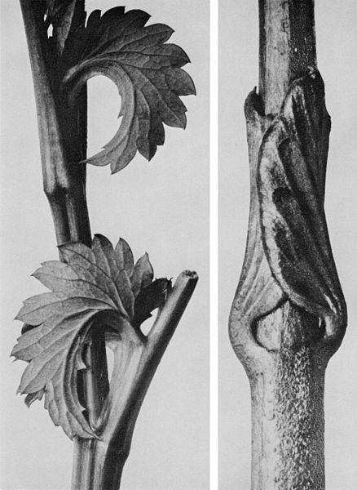
This text came from Wikipedia and a website about Meurer which was linked to Blossfeldt. I selected the Hard Core facts from lots of unnecessary information.
Karl Blossfeldt (June 13, 1865 – December 9, 1932 age 67) was a German photographer, sculptor, teacher and artist who worked in Berlin, Germany. He is best known for his close-up photographs of plants and living things. He was inspired, as was his father, by nature and the way in which plants grow. Especially pansies. Blossfeldt was inspired by his teacher, Meurer to use a microscope to create the magnified images: "We have obtained some nice results recently with microscopic photographs and will continue to use this technique", Meurer wrote in 1892.

Karl Blossfeldt, Canadian burnet
photograph, collotype,

Don’t forget to present your work carefully to explain your understanding. You can use powerpoint or your sketchbook. If your handwriting is poor (like mine) then word process it. Cut out pictures using the paper cutter, not scissors!

