HDR Imaging
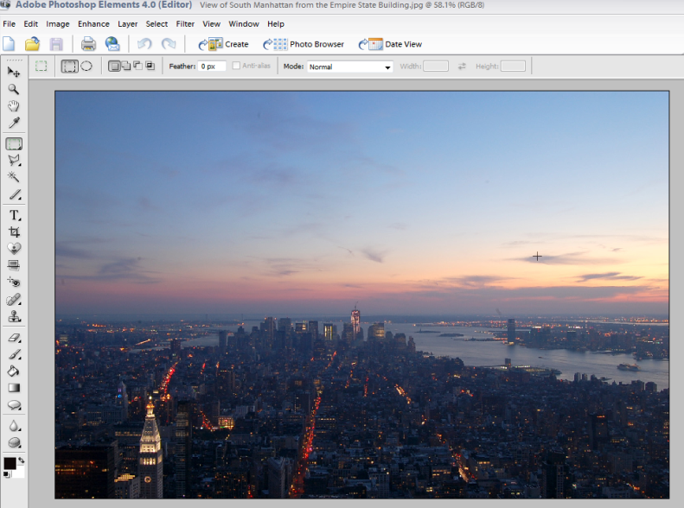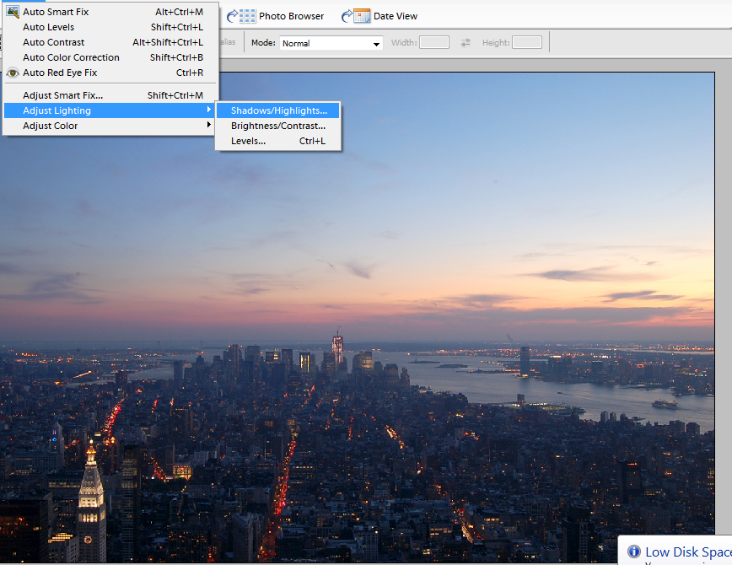
- Open photo in photoshop 2. Go to Enhance – Adjust Lighting – ShadowHighlights
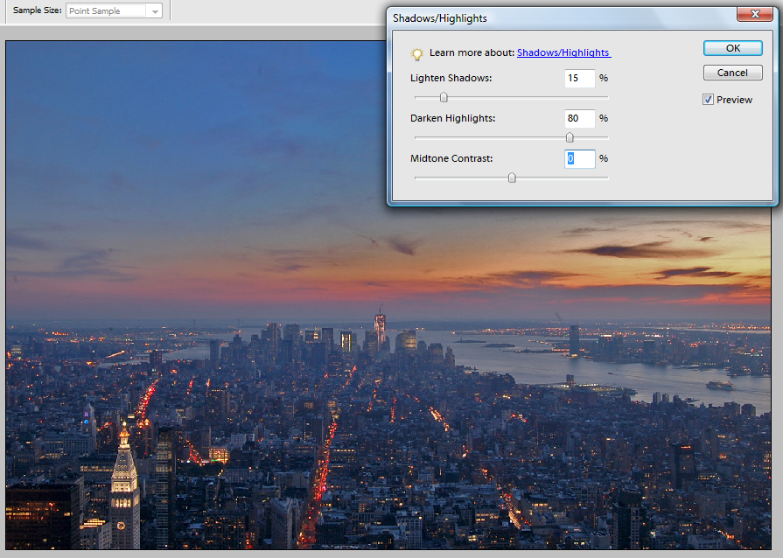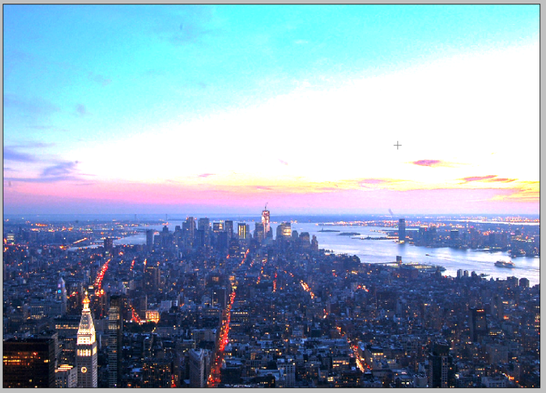
- Lighten shadows to roughly 15, 4. Duplicate the Background layer, set up layer Darken highlights to roughly 80. blending to Colour Dodge
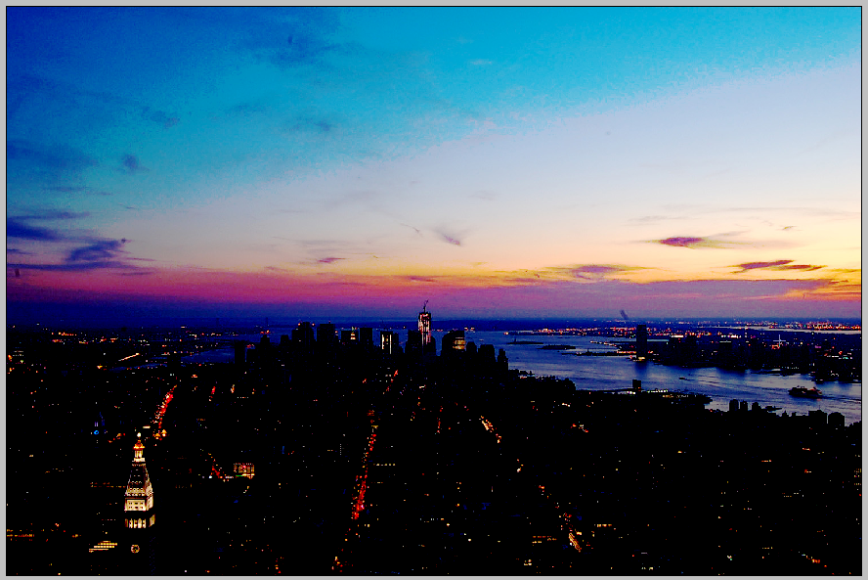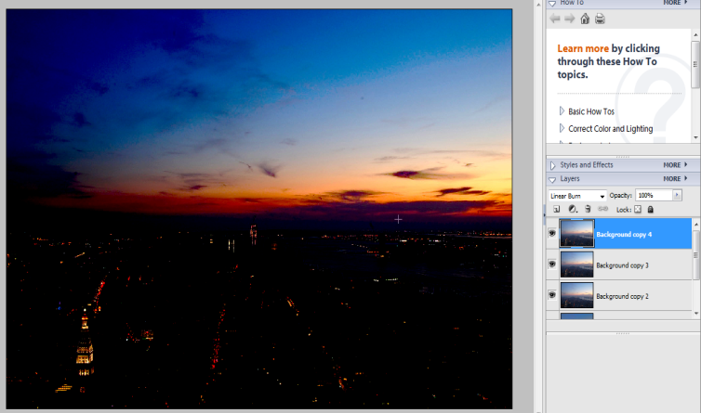
- Do the same as previous but instead Linear Burn. 6. Duplicate the previous layer and set its blending
to Overlay, Now it's time to adjust picture look, try to
experiment with layer opacity.

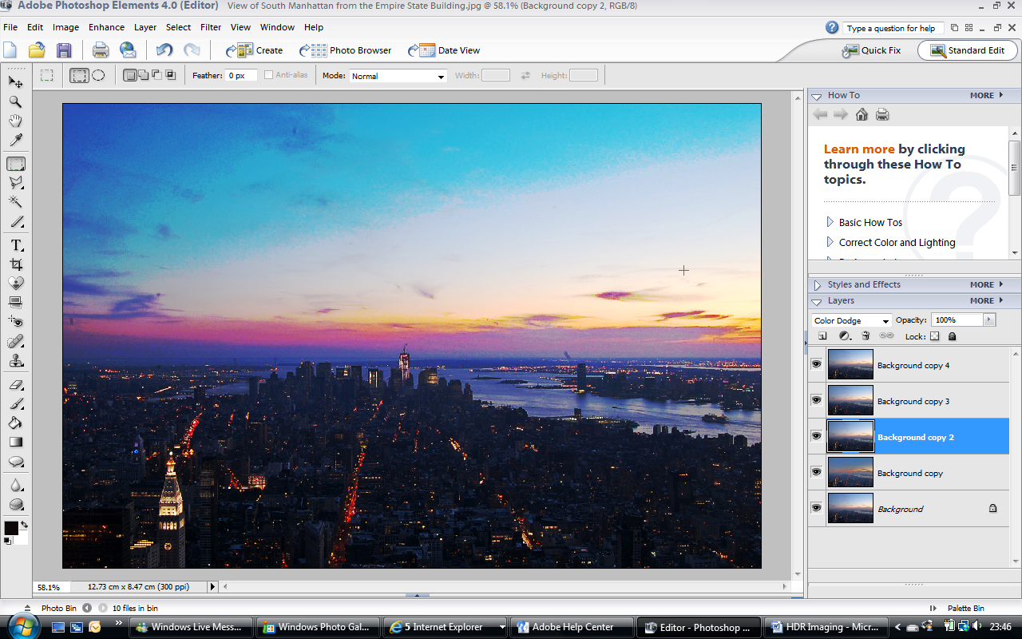
The final version showing HDR colour enhancement. Use your creativity to balance transparency levels to desired effect.

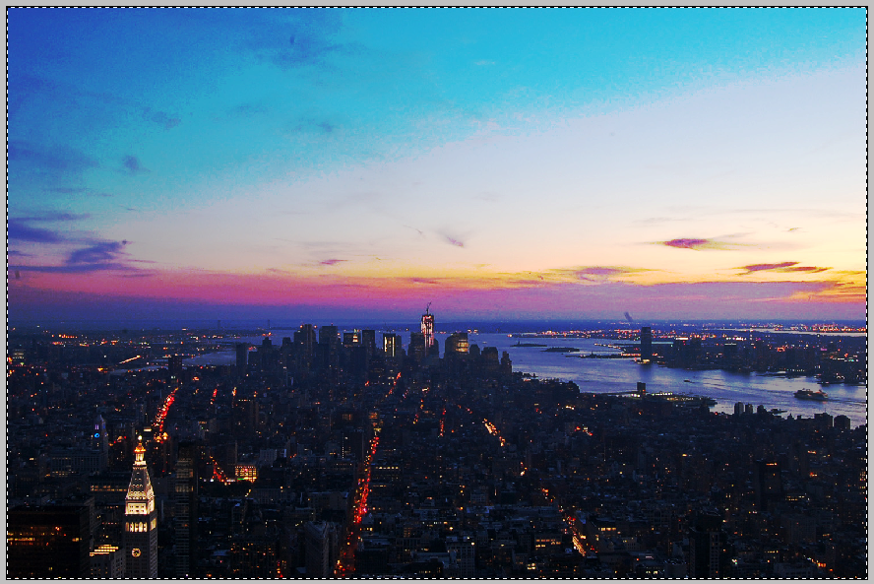
New York from the Empire State Building. Arts Department October 2011

