Life Drawing for 6th formers
All events are at the Old Junior School, South View Road, S7 1HE
7-9pm Life Drawing November 8th and 22nd. Artists: Luisa Golob and Jess MacNair
£6/4 (unwaged)
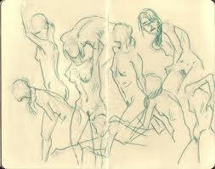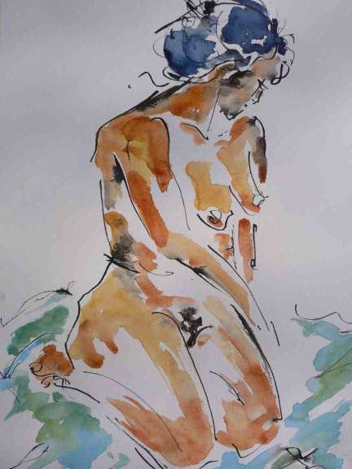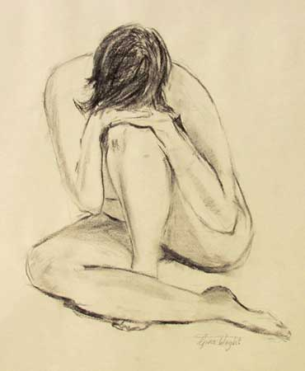

Life Drawing for 6th formers
All events are at the Old Junior School, South View Road, S7 1HE
7-9pm Life Drawing November 8th and 22nd Artists: Luisa Golob and Jess MacNair
£6/4 (unwaged)

