Magritte ‘The Double Secret’
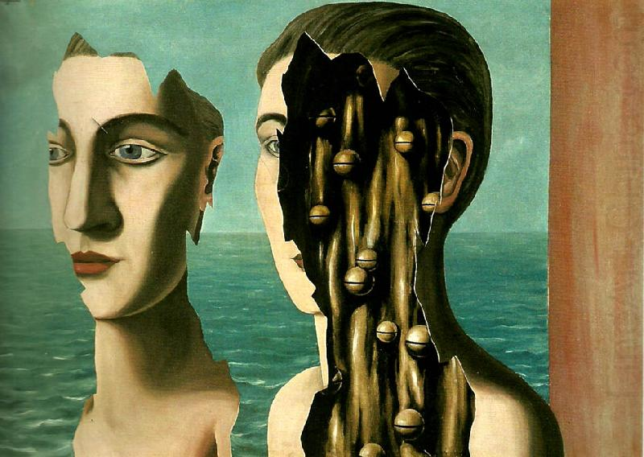
Magritte ‘The Double Secret’

