Planning your ‘Portfolio Lens Based Media Project’
Outline:
You have 25 school weeks (not including holidays) to create a full project based on your chosen ‘starting point’. This will take you to Monday 18th June when the whole project is completed and the final marks are awarded.
The project is made up of 4 parts which are called Assessment Objectives (AO’s). They are marked out of 20 and each one requires you to tackle an aspect of your project. Your teacher will help you to manage this, so please talk to them if you are unsure. Assessment Objective 1 (AO1) This requires you to understand how the artist/photographer has made their image by explaining and copying their work. Assessment Objective 2 (AO2) This requires you to explore and experiment with techniques and ideas of your own relating to your theme. You will create a series of photo shoots for this. Assessment Objective 3 (AO3) This requires you to review and refine your work from the photo shoots. You are likely to use photoshop to do this although you can also re-do photo shoots to get better pictures. Assessment Objective 4 (AO4) This requires you to organise which pictures you want to use from your favourite photo shoot and how you want to present your final pictures to get the best result. Present your final outcome.

Assessment Objective 1 (AO1) 7 weeks Complete

- Create a moodboard of images which relate to your chosen them for your project.
- Write your Project Proposal and hand it to your teacher to get at least 6 specific artists/photographers for you to research.

- Choose one of the artist/photographers, present their image, write an understanding of the process they’ve used (using key words) and copy their picture by creating your own.

- Choose one of the artist/photographers, present their image, write an understanding of the process they’ve used (using key words) and copy their picture by creating your own.

- Choose one of the artist/photographers, present their image, write an understanding of the process they’ve used (using key words) and copy their picture by creating your own.

- Choose one of the artist/photographers, present their image, write an understanding of the process they’ve used (using key words) and copy their picture by creating your own.

- Choose one of the artist/photographers, present their image, write an understanding of the process they’ve used (using key words) and copy their picture by creating your own.

- Choose one of the artist/photographers, present their image, write an understanding of the process they’ve used (using key words) and copy their picture by creating your own.

Assessment Objective 2 (AO2) 6 weeks Field trip: Wednesday 8th February
- Create your own photo shoot possibly inspired by one of your favourite artists/photographers, based on your theme. Experiment with angles, composition, viewpoints. Present the series as a contact sheet (small stamp sized pics). Present your favourite 3 – 4 pictures as A5 (half A4) to show that you are most pleased with these and explain why you like them. Don’t enhance the photos on photoshop!

- Create your own photo shoot possibly inspired by one of your favourite artists/photographers, based on your theme. Experiment with aperture settings.Present the series as a contact sheet (small stamp sized pics). Present your favourite 3 – 4 pictures as A5 (half A4) to show that you are most pleased with these and explain why you like them. Don’t enhance the photos on photoshop!

- Create your own photo shoot possibly inspired by one of your favourite artists/photographers, based on your theme. Experiment with close-up, textures, pattern. Present the series as a contact sheet (small stamp sized pics). Present your favourite 3 – 4 pictures as A5 (half A4) to show that you are most pleased with these and explain why you like them. Don’t enhance the photos on photoshop!

- Create your own photo shoot possibly inspired by one of your favourite artists/photographers, based on your theme. Experiment with different light sources. Present the series as a contact sheet (small stamp sized pics). Present your favourite 3 – 4 pictures as A5 (half A4) to show that you are most pleased with these and explain why you like them. Don’t enhance the photos on photoshop!

- Create your own photo shoot possibly inspired by one of your favourite artists/photographers, based on your theme. Experiment with speed settings. Present the series as a contact sheet (small stamp sized pics). Present your favourite 3 – 4 pictures as A5 (half A4) to show that you are most pleased with these and explain why you like them. Don’t enhance the photos on photoshop!

Assessment Objective 3 (AO3) 6 weeks Field Trip: Friday 9th March
Digital Editing Processes: 1. Converging verticals and sloping horizontals, 2. HDR Imaging, 3. Digital Cross Processing, 4. Digital Cyanotypes, 5. Digital Lith, 6. Digital Infrared, 7. Model World, 8. Panoramas, 9. Small World, 10. Animation, 11. Film.
- Review and refine one of your photo shoots from AO2. Create a better, improved series of photos or use photoshop to digitally edit the work using one of the processes from the list above. Explain what you think of your work and show how you did it by creating a series of ‘print screens’.

- Review and refine one of your photo shoots from AO2. Create a better, improved series of photos or use photoshop to digitally edit the work using one of the processes from the list above. Explain what you think of your work and show how you did it by creating a series of ‘print screens’.

- Review and refine one of your photo shoots from AO2. Create a better, improved series of photos or use photoshop to digitally edit the work using one of the processes from the list above. Explain what you think of your work and show how you did it by creating a series of ‘print screens’.

- Review and refine one of your photo shoots from AO2. Create a better, improved series of photos or use photoshop to digitally edit the work using one of the processes from the list above. Explain what you think of your work and show how you did it by creating a series of ‘print screens’.

- Review and refine one of your photo shoots from AO2. Create a better, improved series of photos or use photoshop to digitally edit the work using one of the processes from the list above. Explain what you think of your work and show how you did it by creating a series of ‘print screens’.

Assessment Objective 4 (AO4) 6 weeks
- Explore how you want to present your pictures. Consider: Photobook, In Series, Enlargement, Wall Art, Ink Jet Transfers, CD design, Web Design, Animation, Film.

- Create a fully realised and complete final image that is the best quality that you can manage. If you need to create more photo shoots or take more footage then do so. Show how you made decisions by recording your evidence in your presentation.

- Present your whole project to demonstrate your full understanding of the processes used. If necessary use annotation to explain your decision making. Don’t assume that I will know what you have done. If unsure, explain it!

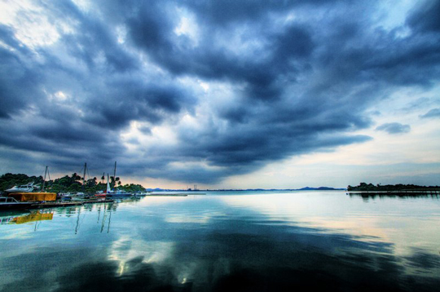 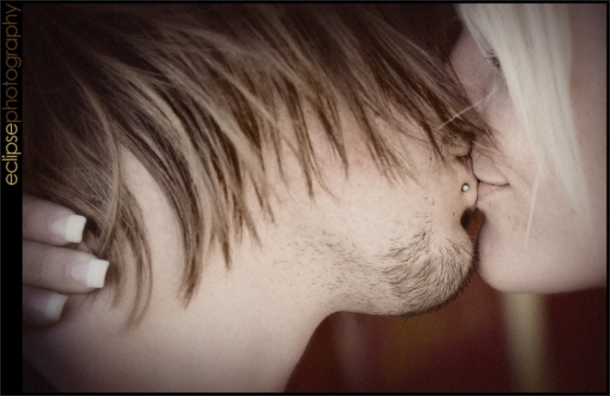 HDR Photography Digital Cross Processing

