What is Objective 3?
- It evolves from the experiments and ideas that you explored in objective 2
- You focus on your favourite / best idea
- You collect photos helping you to make your final piece (AO4)
- You organise your design for your final piece (composition)
- You draw and paint aspects of your photos to develop your confidence and understanding
- You plan how you are going to use the 10 hours you have to make your final piece in exam conditions. Remember you want to use all the time to show the depth of your ability.
- You begin your final piece with 3 hours during the last week before Easter. This will be Monday Morning 4th April, 9.00 – 12.20. The rest of the 7 hours will happen in lesson after Easter.
- You can carry on making work for all 3 objectives while you are making your final piece. The project ends and everything is handed in at the end of the 10th hour.
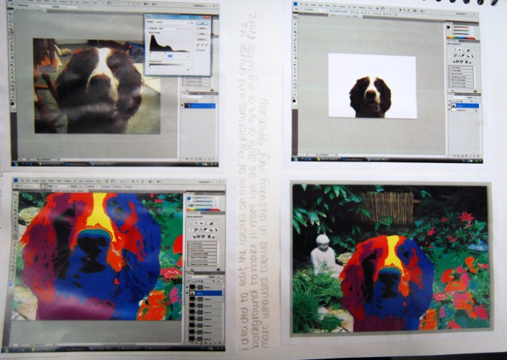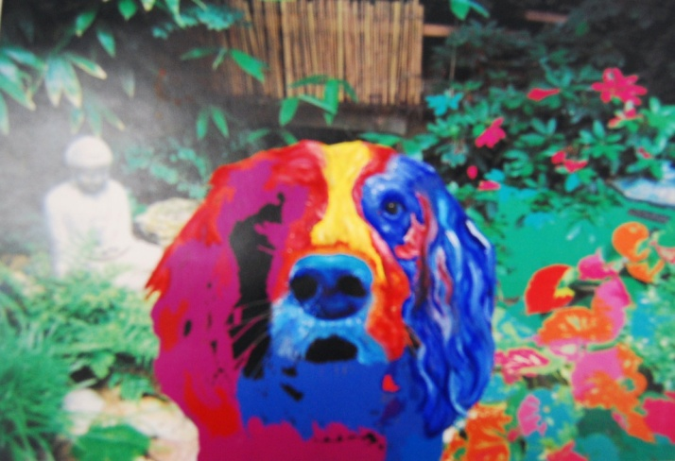What is Objective 3?
- It evolves from the experiments and ideas that you explored in objective 2
- You focus on your favourite / best idea
- You collect photos helping you to make your final piece (AO4)
- You organise your design for your final piece (composition)
- You draw and paint aspects of your photos to develop your confidence and understanding
- You plan how you are going to use the 10 hours you have to make your final piece in exam conditions. Remember you want to use all the time to show the depth of your ability.
- You begin your final piece with 3 hours during the last week before Easter. This will be Monday Morning 4th April, 9.00 – 12.20. The rest of the 7 hours will happen in lesson after Easter.
- You can carry on making work for all 3 objectives while you are making your final piece. The project ends and everything is handed in at the end of the 10th hour.

