Y10 GCSE Art
Welcome to the new course.
You get an A2 sketchbook to use.
Coursework deadlines:
7 weeks to do objective 1. Hand the work for assessment on Wednesday 4th November
Art trip to Manchester – Wednesday 30th September.
7 weeks to do objective 2. Hand the work in for assessment on Friday 8th January
7 weeks to do objective 3. Hand the work in for assessment on Wednesday 3rd March
6 weeks to do objective 4. Hand the whole project in for assessment on Wednesday 28th April
Most of the work will be done in sketchbooks but you can produce sheets of work as well.
Objective 1 requires you to explore a variety of different artists’/designers’/photographers’/craftspeoples’ work and to produce visual and written evidence that shows how much you’ve learnt from them. The art peoples’ work that you study will depend on the focus that you have for your project.
To find the focus of your project you need to do a few mind showers:
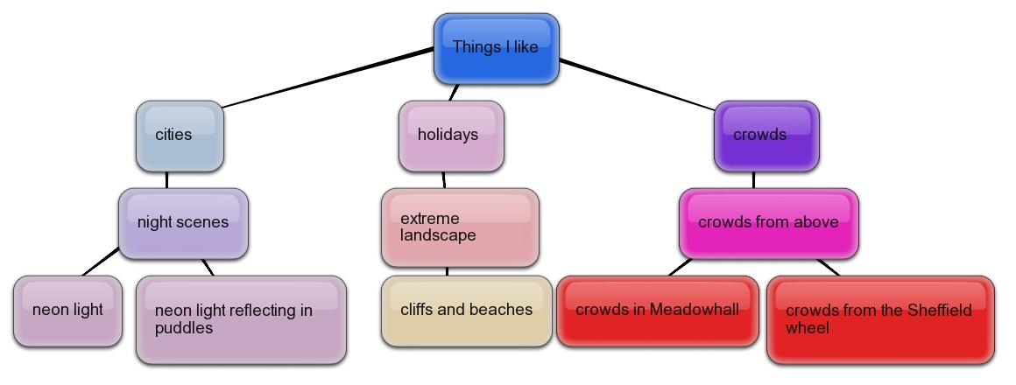
http://bubbl.us/edit.php
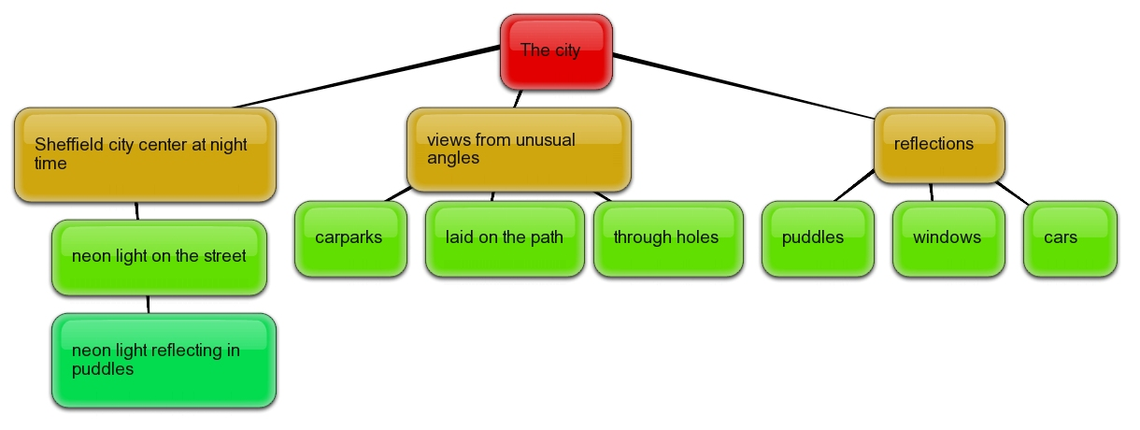
Once you have an area of focus you need to record your 2 favourite ideas on the proposal sheet and give it to Mr Longmuir before the end of the lesson and he will find some relevant artists for you to start working from next lesson.

