Y10 Portfolio Project
- The students first need to choose the starting point for their project which will give focus to their research. At this stage the focus needs to be broad (such as ‘the landscape’ or ‘the figure’) as they will become more selective as the project evolves.
- They need to collect as many images as possible to inform their research from magazines, internet, photos, film stills, (screen shots) and collage a mood board. This will help them to begin the job of taking images and exploring the creative potential using a broad range of processes. Below are a series of processes which can be explored although the teacher is expected to use their own experience. They can be done in any order.

Photography:

As there are 8 SLR cameras and roughly 24 students in each group, it is a good idea to divide the group into teams of 3. (there may be students with their own SLR digital cameras which will help with the group sizes) The students can then help each other with the photography and share the experience. (the exam board allow group work as long as the individual identifies their own contribution). Each group needs the laminated ‘Guide to using the SLR camera’ as a reference.

Exercise 1: Exposure and Stops

In the simplest terms, exposure is: “is the total amount of light allowed to fall on the photographic medium during the process of taking a photograph”
The variation of brightness in the real world is absolutely huge, much more than you might think from your subjective experience of it. A subject lit by the midday sun on a beach looks over four thousand times brighter to your camera than the same subject lit by the quarter moon! Brightness is measured in “Exposure Value” or EV.

Controlling Exposure
To accommodate the huge variety of brightness levels we see in the real world, we need to be able to control how much light gets to the camera’s sensor. We do this by adjusting one or more of the three points of the “exposure triangle”. These three points are ISO, Shutter and Aperture.
The aperture is an adjustable iris or opening that can be made wider to let in more light, or narrower to let in less. The shutter is the “gate” that allows light onto the sensor, and it can be left open for different lengths of time, to let the sensor collect more or less light. Finally, the ISO once referred to the sensitive to light of the film in the camera. In digital cameras it refers to the “gain”, or amplification of the information collected by the sensor. In film days, changing ISO meant changing films. Today the ISO can be easily adjusted with a dial.
http://digital-photography-school.com/photography-1014-exposure-and-stops
Tasks:
- Using the button on the camera, and a tripod, photograph the same object or scene showing a full range of exposure stops. (this is demonstrated on the example below) This needs to be printed by every student and presented in the sketchbook with an explanation of the process.
- Set your camera to full auto, find various scenes, and “half press” the shutter and see what exposure settings it recommends. Now go to manual, make the settings using the manual control and take the photo. Repeat until you feel comfortable adjusting the manual settings.
- Apply these lessons artistically. Experiment with deliberately over or under exposing photos (high and low-key photos) or tweaking the auto exposed settings to emphasise otherwise under or over exposed areas. Print your favorite photo and present it in your sketchbook with an explanation of the process.
The “Stop” A step up (doubling) or down (halving) by one EV is called a stop.
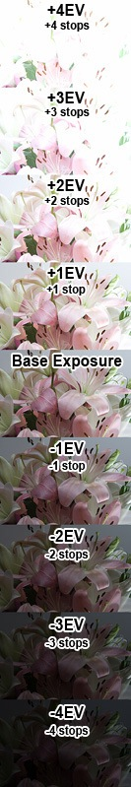
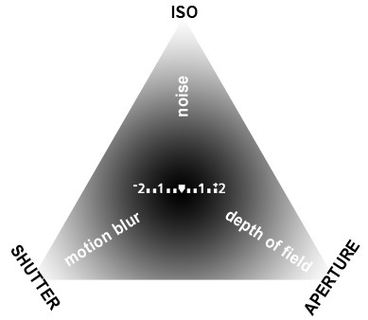
Neil Creek is a professional photographer from Melbourne, Australia. He has been shooting with a DSLR since 2004, and blogging about his experiences since 2006. The focus of his writing today is about the journey he is taking from amateur to professional. View Neil's folio at his home page. Read his photography writing at his blog. Connect with him on Twitter. Follow me on Twitter, username: neilcreek

Exercise 2: Aperture
The iris opens and closes to change the aperture.
The word aperture simply means “an opening” (reference.com). In the case of photography, the aperture is created by an adjustable iris that can be opened or closed to control how much light enters the camera. With our adjustable aperture, we can do a very neat trick. The aperture acts on the lens as if it is cutting away the part of the lens which is covered. So as we stop down the aperture, we effectively make the lens smaller, and thus change the f ratio of the lens. As such, the size of the aperture is described by the f ratio that it creates. A wide aperture may be f2.8, a narrow aperture may be f22.
The f ratio sequence in stops.
1 - 1.4 - 2 - 2.8 - 4 - 5.6 - 8 - 11 - 16 - 22 – 32

Depth of Field
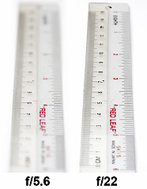 A narrower aperture has a much greater depth of field. If we look again at the exposure triangle diagram in lesson 1, you’ll see that the aperture influences the depth of field. The depth of field is the region of the photo which is in focus when the image is captured. It is a range of distance from the camera where objects look to be in focus. Aperture influences the depth of field by widening or narrowing this range, thus bringing more or less of the photo into focus, based on its distance from the camera.
The most important thing to remember is that a wide aperture (low value) means a shallow depth of field with less in focus and a narrow aperture (large value) means a broad depth of field with more in focus.
Tasks:
- Find a scene with interesting stuff at many distances from you. Photograph the scene with different apertures (keeping the photo exposed correctly by changing shutter speed), and see the difference in the depth of field. Print small sized examples of your photos to present in your sketchbook.
- Find a small subject that stands against a background a few meters away, like a flower. Try adjusting the aperture to isolate the subject from the background with depth of field. Print small sized examples of your photos to present in your sketchbook.
Photographic Assignments:

The Decisive Moment Henri Cartier Bresson was a French photographer working in the middle of the 20th century. He is famous for using a small instant camera to take photographs of people in the city. He would wait like a hunter for hours till he caught the best photo possible. "Photography is not like painting," Cartier-Bresson told the Washington Post in 1957. "There is a creative fraction of a second when you are taking a picture. Your eye must see a composition or an expression that life itself offers you, and you must know with intuition when to click the camera. That is the moment the photographer is creative," he said. "Oop! The Moment! Once you miss it, it is gone forever." Using Henri Cartier Bresson’s photographs as an inspiration, create your own body of photographs inspired by the decisive moment. Other photographers inspired by Bresson were Garry Winegrand, Ray Metzker and Robert Doisneau. 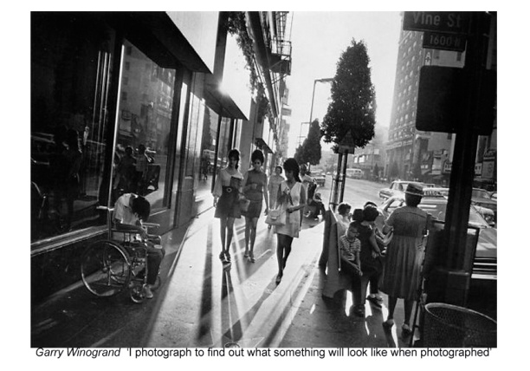 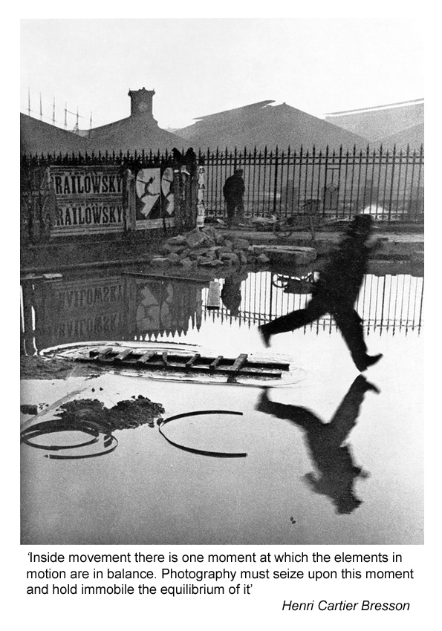 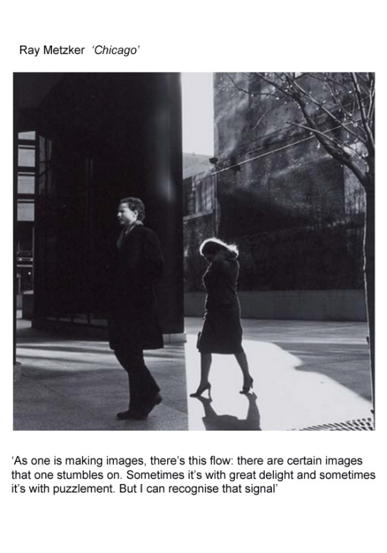 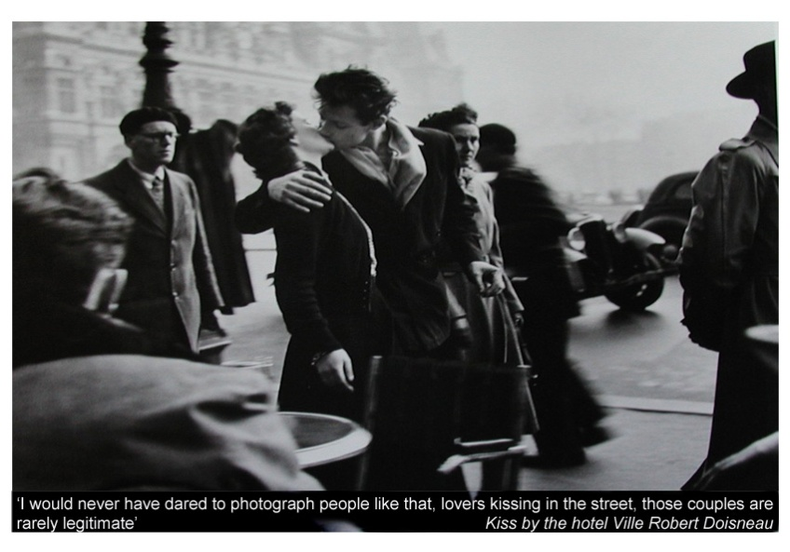

2. The "joiners"
David Hockney has also worked with photography, or, more precisely, photocollage. Using varying numbers of small Polaroid snaps or photolab-prints of a single subject Hockney arranged a patchwork to make a composite image. Because these photographs are taken from different perspectives and at slightly different times, the result is work which has an affinity with Cubism, an affinity which was one of Hockney's major aims - discussing the way human vision works. Some of these pieces are landscapes such as Pearblossom Highway #2,^{[1][2]} others being portraits, e.g. Kasmin 1982,^{[3]} and My Mother, Bolton Abbey, 1982.^{[4]}
Using Hockney’s ‘joiners’ photographs as an inspiration and Picasso’s ideas for recording various viewpoints at the same time, create your own series of photographic compositions based on your own subject.
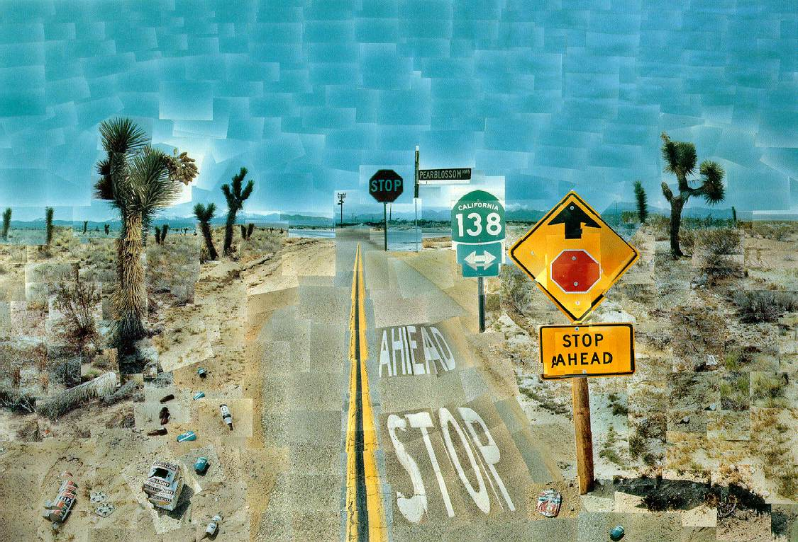
http://www.ibiblio.org/wm/paint/auth/hockney/hockney.pearblossom-highway.jpg
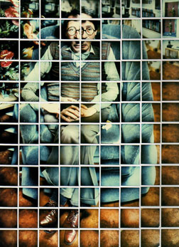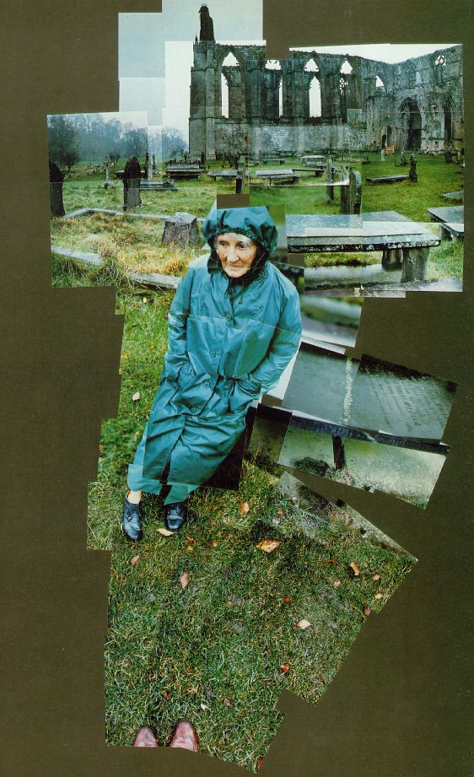
http://www.newyorksocialdiary.com/contributors/artset/images/11_18_04/kasmin.jpg
http://www.artchive.com/artchive/h/hockney/hockney_my_mother.jpg
- Peter Beard Diary 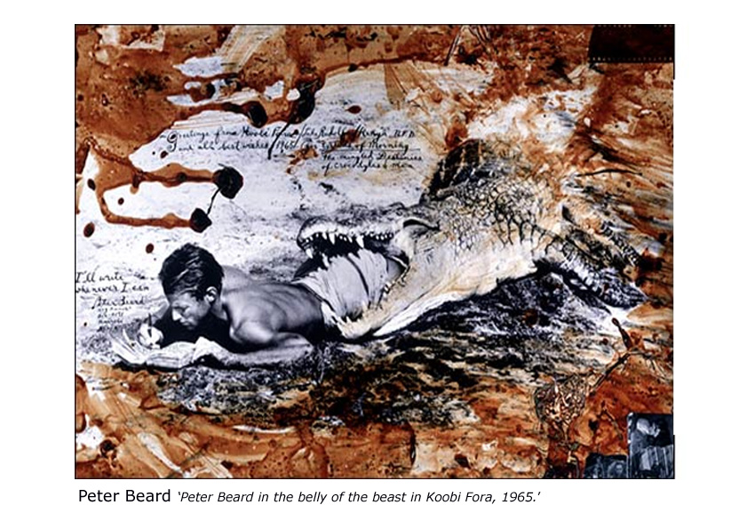
http://www.peterbeard.com/index.htm
Using the Peter Beard website, find out his opinions about the fate of Africa’s wildlife. Create your own visual diary using photographs, collage, found materials and text to highlight an issue that you are passionate about.
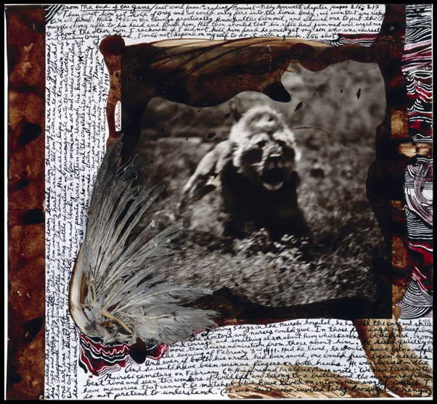

- Annie Leibovitz and Cindy Sherman story telling 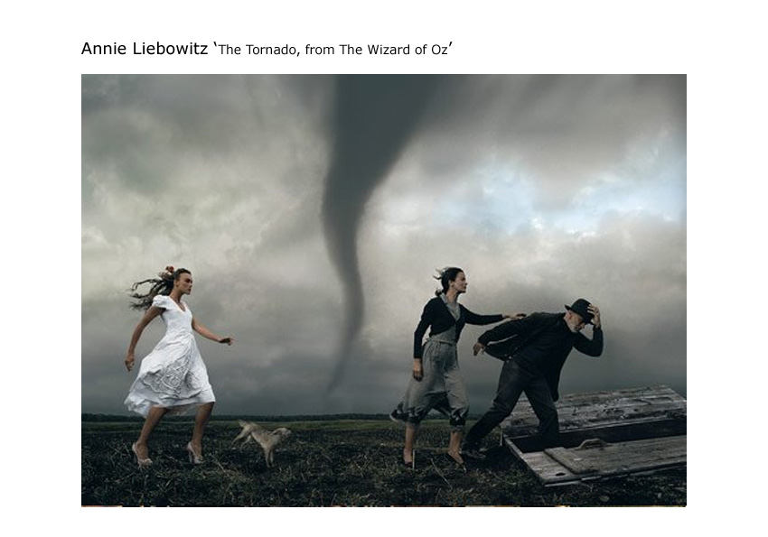
http://www.pbs.org/wnet/americanmasters/episodes/annie-leibovitz/life-through-a-lens/16/
Annie Leibovitz uses photography to tell visual stories or to re-enact famous scenes from stories or films. Cindy Sherman has also used herself to act out key scenes from famous films. Research their work on the internet and tell your own visual stories or recreate your own scenes from films.
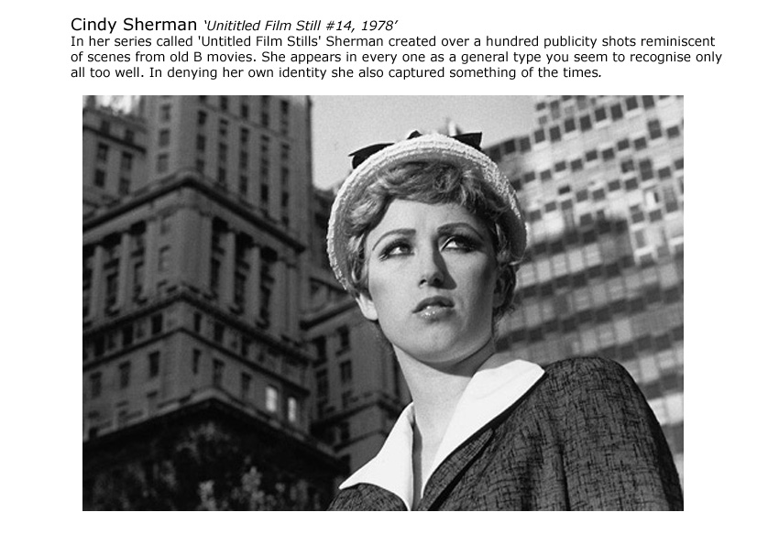
www.metmuseum.org
- Photoshop your own digital collage
Use the ‘Photoshop Creative’ magazine to create a digital collage using your own photograph and scans of drawings and paintings.

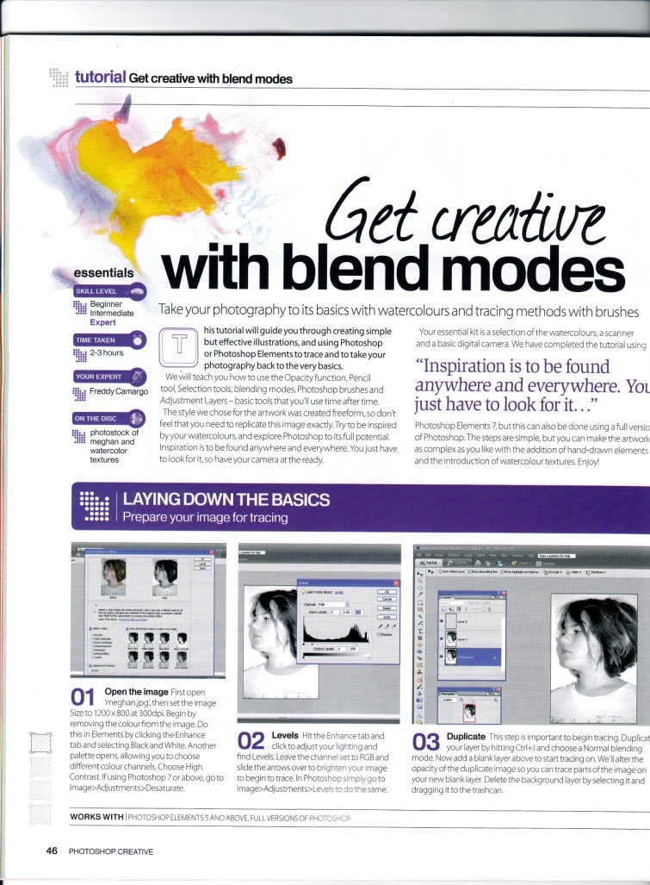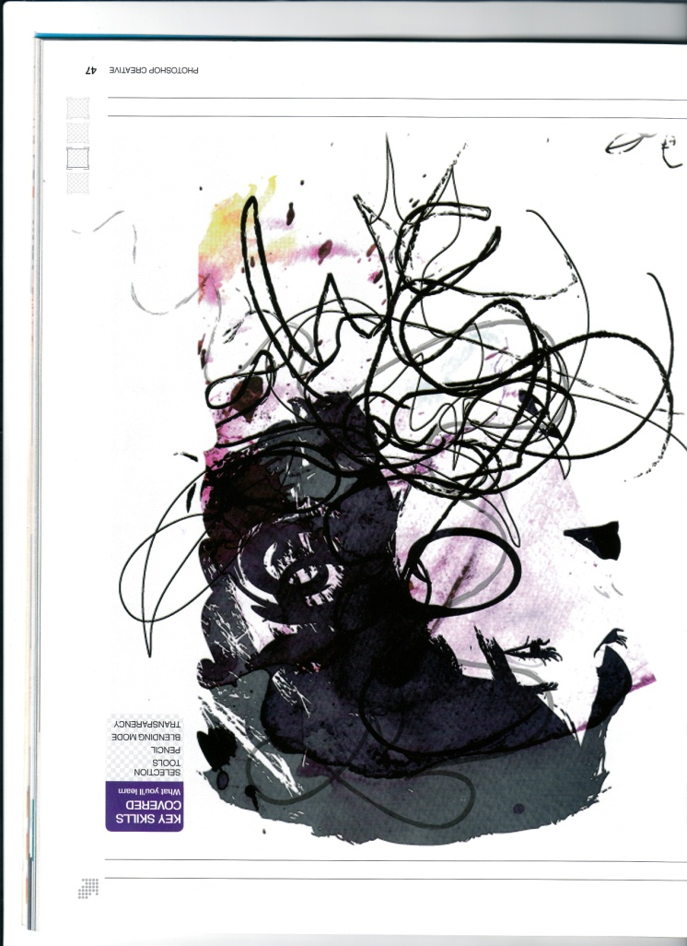

http://www.photoshopcreative.co.uk/tutorials.php

- Inspired by art
Jeff Wall, Seydou Keita and Wang Quinsong have all been inspired to create photographs that have been inspired by famous works of art or other cultures. Research the work of the photographers and create your own versions of art that inspires you.
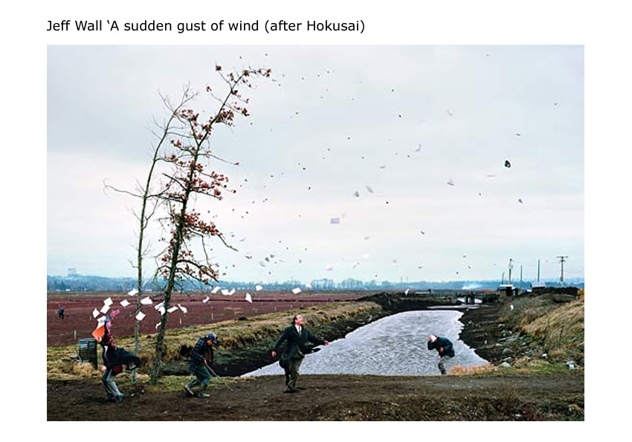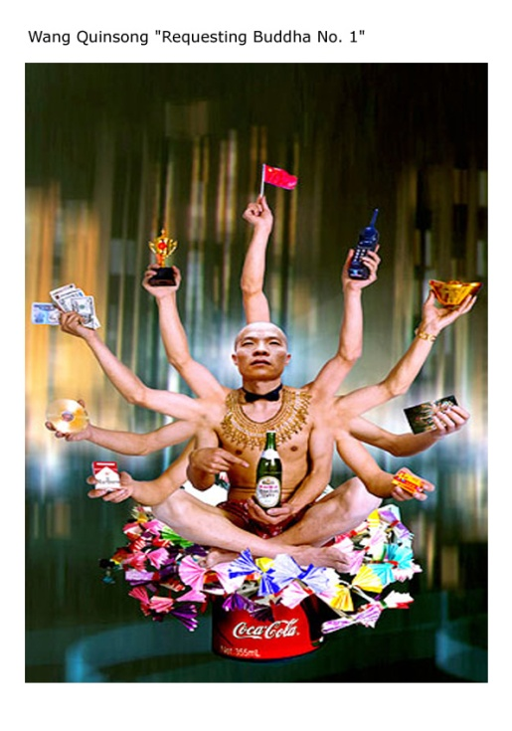
http://en.wikipedia.org/wiki/Jeff_Wall http://www.wangqingsong.com/html/index.htm

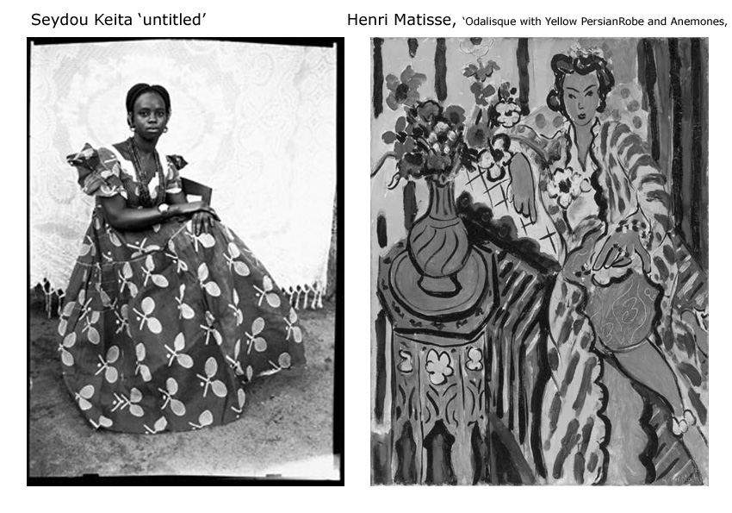
http://www.zonezero.com/EXPOSICIONES/fotografos/keita/default.html

