Y10 Portfolio Project
- The students first need to choose the starting point for their project which will give focus to their research. At this stage the focus needs to be broad (such as ‘the landscape’ or ‘the figure’) as they will become more selective as the project evolves.
- They need to collect as many images as possible to inform their research from magazines, internet, photos, film stills, (screen shots) and collage a mood board. This will help them to begin the job of taking images and exploring the creative potential using a broad range of processes. Below are a series of processes which can be explored although the teacher is expected to use their own experience. They can be done in any order.
Drawing:
The student needs the list of appropriate artists associated with their chosen starting point for the project. From that list they need to have collected several images that they are going to use to produce evidence for assessment objective 1 or 3. Ensure that the students get into the habit of referencing where the images come from: website address, and that they are labelled fully with the name of the artist and title of the artwork. They will need to be taught this.
Exercise 1: Pencil.
Start the pencil experience with shading exercises which the students use to demonstrate a broad range of shading tones in their sketchbook. Also do some texture exercises to demonstrate how pencil can describe a variety of textures in the sketchbook. Following the tone and texture work the students copy either one of their own photos or an artist’s work to as high a standard as possible. Note that the drawing does not need to be finished, but what is drawn is completed to as high a standard as possible according to the assessment objectives. Assessment: The students need to rate their work in terms of how well they have managed pencil to describe shape, tone, detail and texture accurately and with control. The teacher assesses using the AQA assessment criteria 1 – 20. http://store.aqa.org.uk/qual/newgcse/pdf/AQA-4200-W-SP-10.PDF
Exercise 2: Ink.
Use either biro or dipping ink to create a sketchbook page of line studies. Start the exercise with some explorations of biro and ink including: cross hatching, thick/thin line, blown diffuser ink effects, drip/spatter ink effects. Discuss the results together and establish when certain effects would be useful. Next to the studies the student draws a sustained picture which uses as many of the effects as possible to achieve a creative yet sensitive use of the materials. Assessment: The students need to rate their work in terms of how well they have managed ink to describe shape, tone, detail and texture and pattern accurately and with control. The teacher assesses using the AQA assessment criteria 1 – 20. http://store.aqa.org.uk/qual/newgcse/pdf/AQA-4200-W-SP-10.PDF
Exercise 3: Oil and chalk pastel.
Explore the mark making qualities of the 2 different drawing materials. Present the explorations next to each other on a sketchbook page so that comparisons can be made. The student can decide how they are going to present the work. Using a photograph or artist image as a reference, the students create a colour study using either chalk or oil pastel. They need to evaluate their results and explain why they made the choice for either oil or chalk pastel. Assessment: The students need to rate their work in terms of how well they have managed pastel to describe atmosphere and mood with control and understanding for purpose. Teacher assessment as above.

Exercise 4: Wire.
Discuss drawing with a single line to define a shape to explain an imaginative idea. This won’t be from observation but will be imagined. Look at the wire drawings of Calder to help make the point.
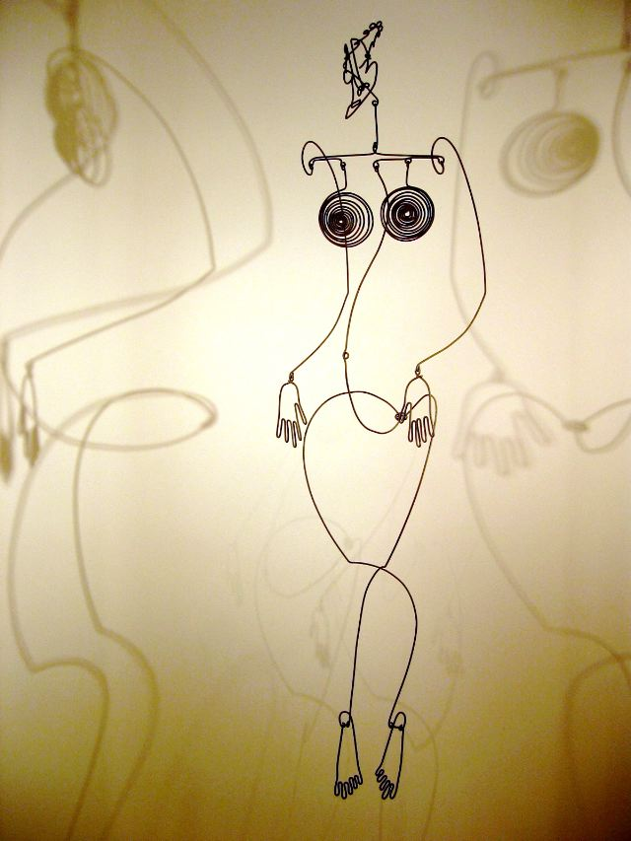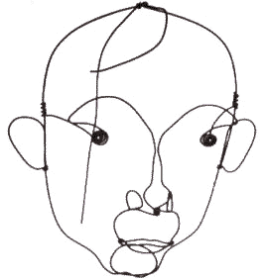
http://matterful.files.wordpress.com/2008/11/calder.jpg http://www.artmag.com/museums/a_spain/aspbami/calder/calder1.gif
The students draw their imagined line without taking their pen off the page to practise the effect of a single line drawing. When ready they draw using wire. Results can be photographed with shadows and attached in the sketchbook.
Exercise 5: Stitching. Look at art which shows drawings using a stitched line. Students could create stitched drawings in their sketchbooks. If they are inspired they could develop the process with different surfaces and collage materials.
. 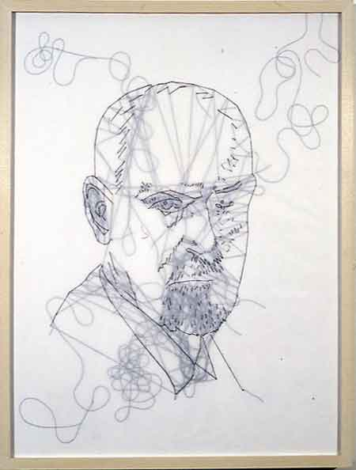 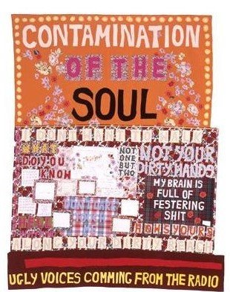
http://www.supernaturale.com/img/articles/236/4885.jpg Tracey Emin http://www.myartspace.com/blog/uploaded_images/Tracey-Emin-2-753725.jpg

